**Launching an EC2 instance Using EC2 USer Data**

**·**  We will be launching our virtual server using the AWS console

· We will get a high-level approach to various parameters.

· Also we will be seeing at our web server is launched using EC2 user data

**Step 1: Open your Aws Console**

Type the word "EC2" into your search box, then click on the EC2(Virtual server in the cloud)

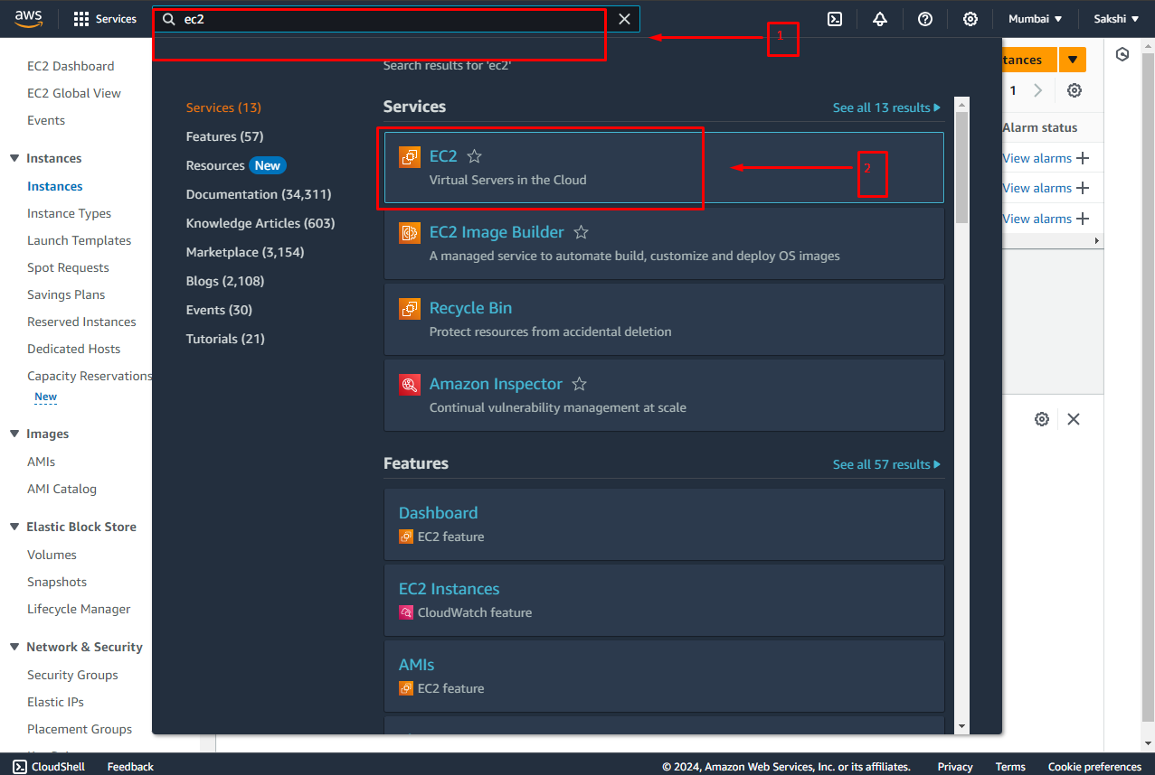

**Step 2 : Launch Instance**

1. Click on instance

2. Then click on Launch Instance

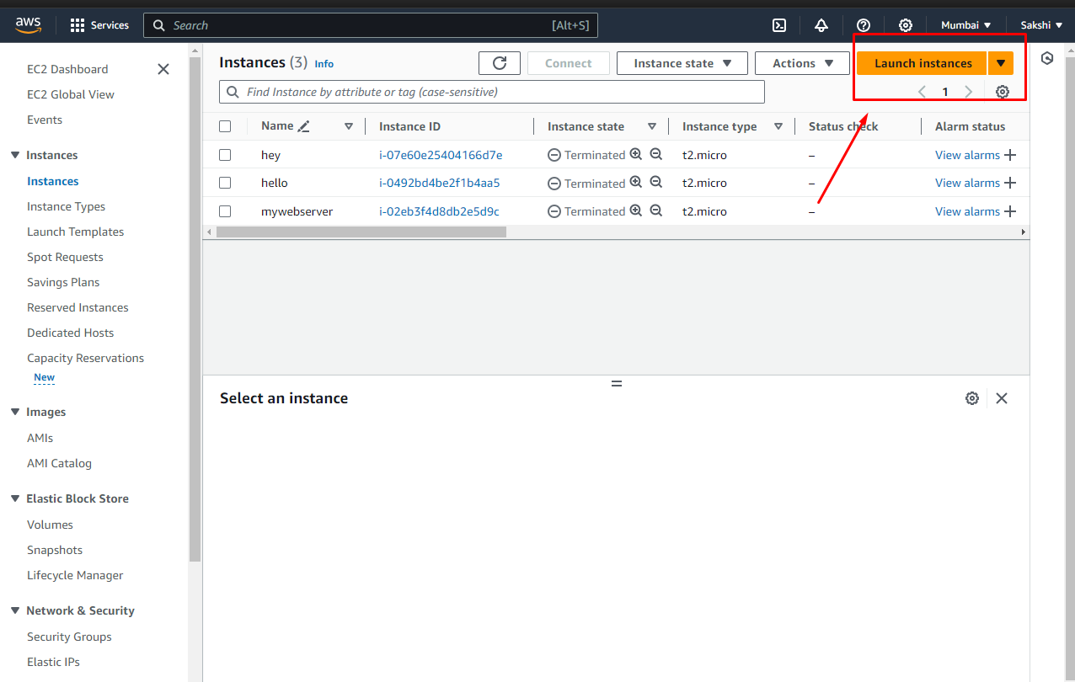

**Step 3: Give name to your Instance and select AMI**

1. Add a name tag for you instance

2. Also select a AMI (Amazon machine image) (An AMI is a template that contains the software configuration (operating system, application server, and applications) required to launch your instance. Search or Browse for AMIs if you don’t see what you are looking for below)

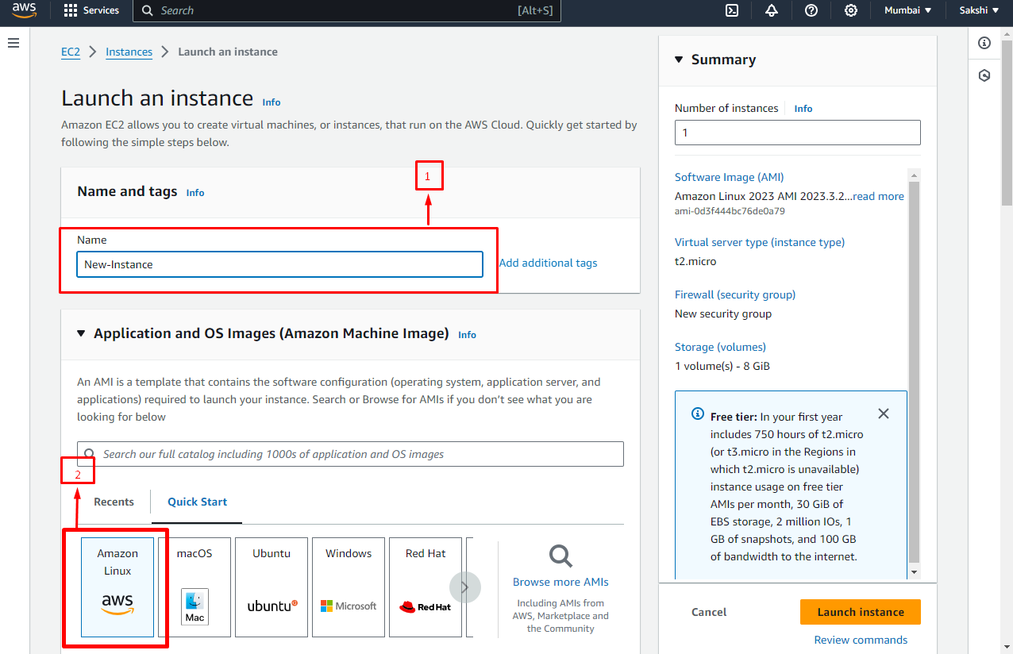

**Step 4: Create New Key pair**

(Key pair is necessary if we use ssh utility to access our instance ,Therefore we have to create a keypair here)

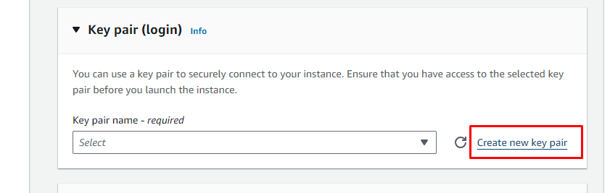

**Step 5 : Give name to your Key pair**

1. The name is going be EC2-key-pair.

2. Then we will select RSD encryption.

3. Select .pem as your Private Key File Format

(So remember if you have **mac, linux or windows 10** then you can use the **.pem format** but if your **windows version is lesser than windows 10 For example 8,7 or 6** then you should be using **.ppk format** via using putty and putty is how you do ssh on window 7 or 8)

4. Click on “**Create Key pair**”

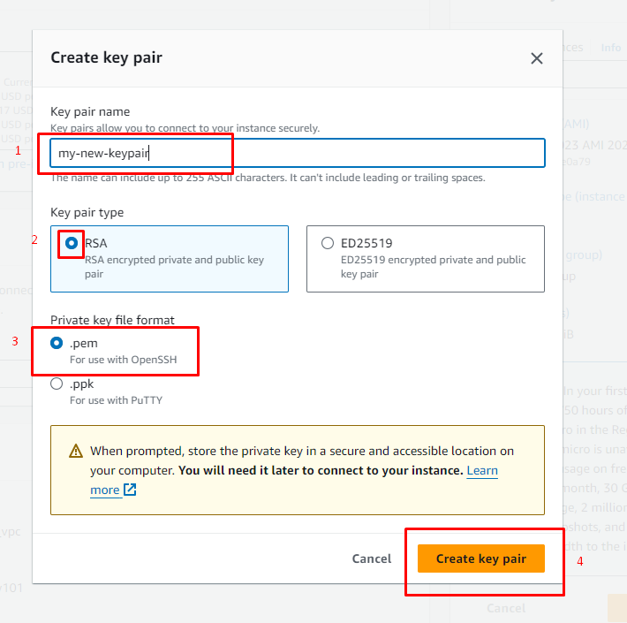

* We will see now network setting as of now we will just change the auto assign public ip its **disable by default** you have to **enable** it

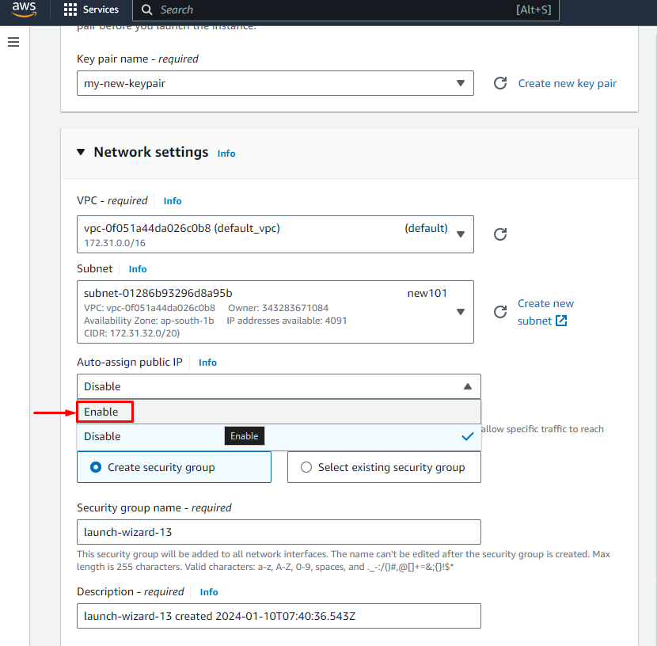

**Step 6: Create a Security Group**

(A security group attached to our instance which is going to control the traffic coming from and to our instance)

1. Therefore we can add rules the first security group that will be created is launch-wizard-13 created by the console directly

And we can define multiple rules

2. First allow SSH traffic from anywhere

3. Secondly allow HTTP Traffic from anywhere (We also want to allow http traffic from the internet so as we are going to launch our web server on our ec2 instance so we need that as well. Else we we will keep everything as it it

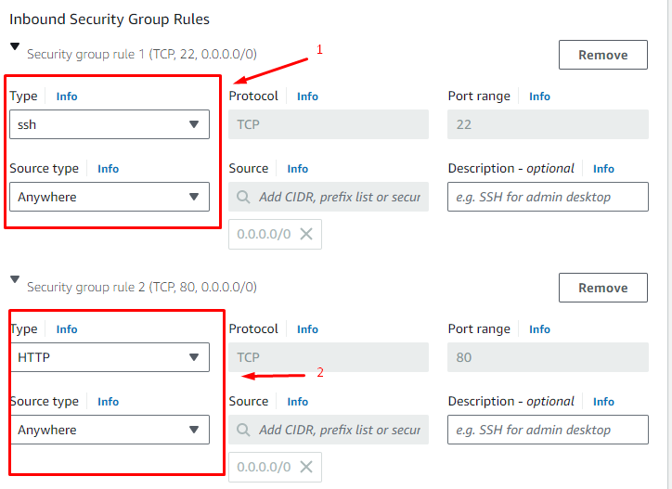

**Step 7: Advanced Setting to add user data script**

1 .Click on Advance Details

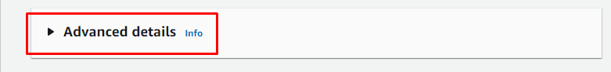Now we scroll down will go all the way to the bottom then at the bottom there user data user data is when we pass

(User data is when we pass a script Comments to our ec2 instance to execute on the first launch of the ec2 instance and only on the first launch )

**Copy the Code given below**

#!/bin/bash

# Use this for your user data (script from top to bottom)

# install httpd (Linux 2 version)

yum update -y

yum install -y httpd

systemctl start httpd

systemctl enable httpd

echo "<h1>Hello World from $(hostname -f)</h1>" > /var/www/html/index.html

**Paste this code in the user data section**

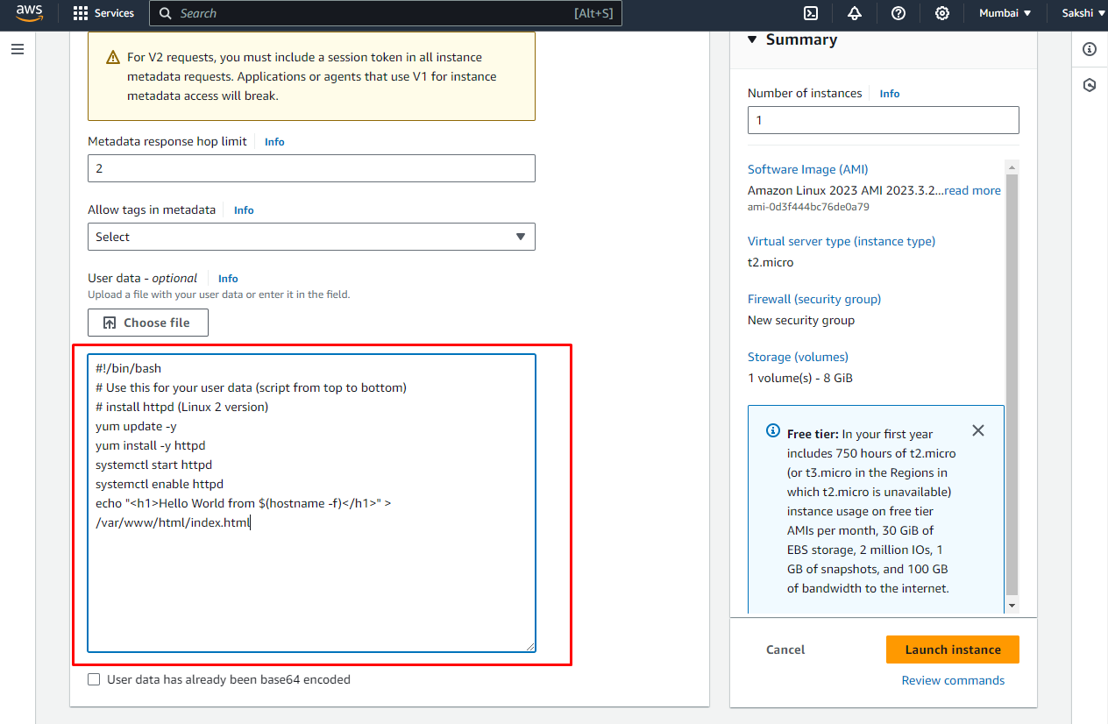

Now this script is going to be executed when the instance is first started in the whole lifecycle of the instance So what we are going to do is update few things , then install the httpd webserver on the machine and then write a file an html file that will be a webserver

**Click on Launch instance**

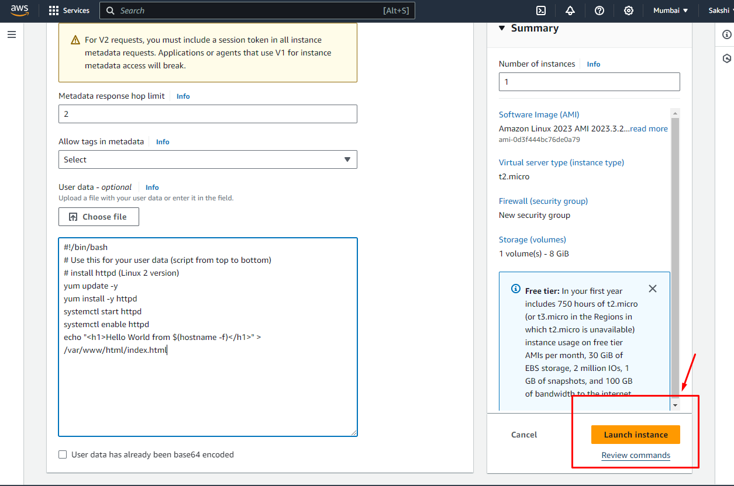

We can now see that our instance is running (it may take 3 to 5 minutes to launch your instance

So let's have a look my web server is running on my instance

1. First you have to copy your Public Ip Address

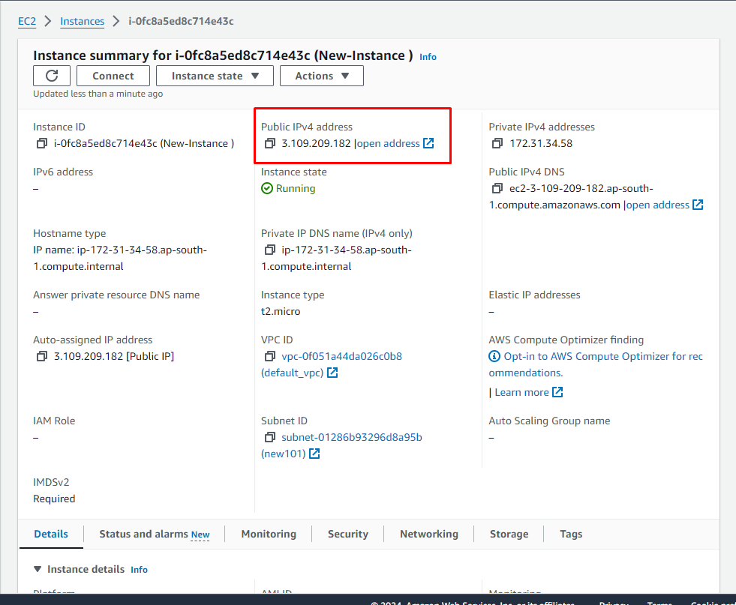

2. Then you paste it here

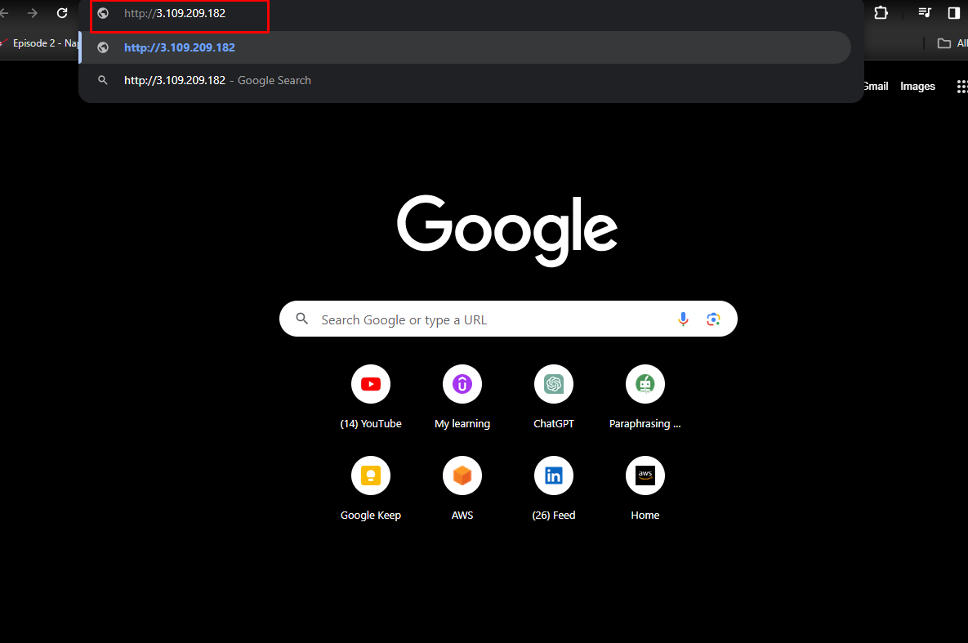

You can see here that hello world got displayed so we can see our web server running

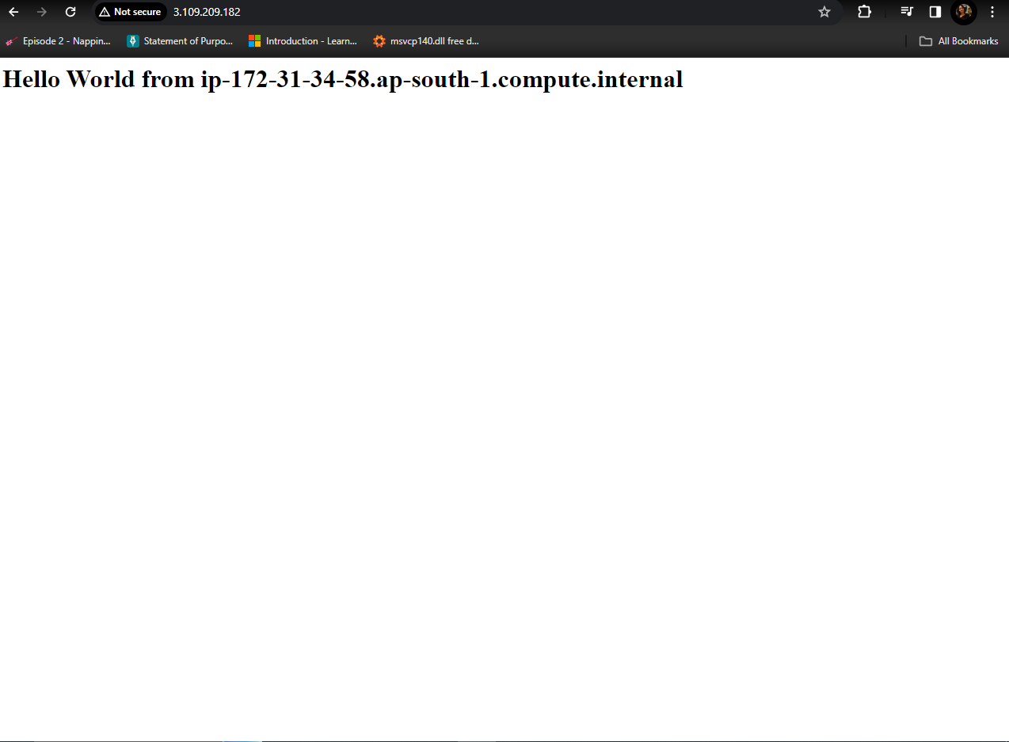

We can see here our Ec2 instance is running but if we don't need it we can go to **Instance State** and then click on stop instance.

In cloud you can stop or start instance as you wish

Why would you stop an instance? The longer you leave it running the more you going to pay but if you decide to stop an instance then AWS will not bill you for that.

**Steps 1 : Stop An Instance**

* + - 1. Go to Instance State and click on Stop Instance

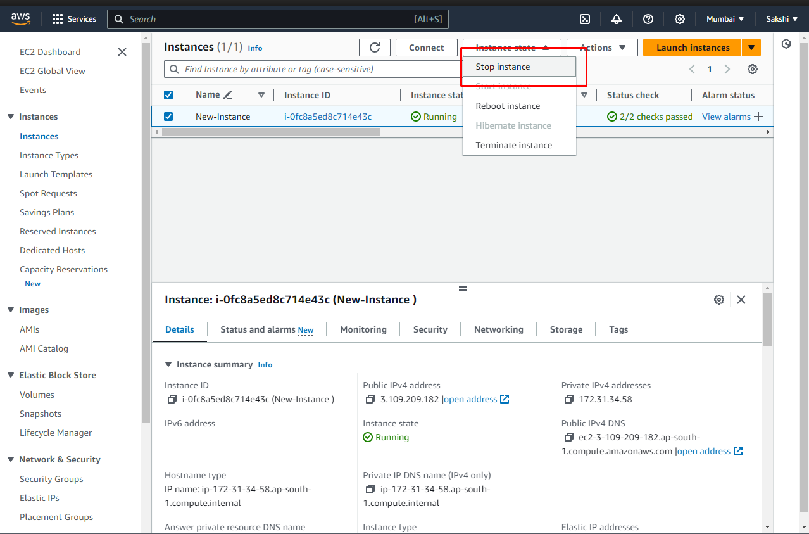

We can now see here the instance is stopped

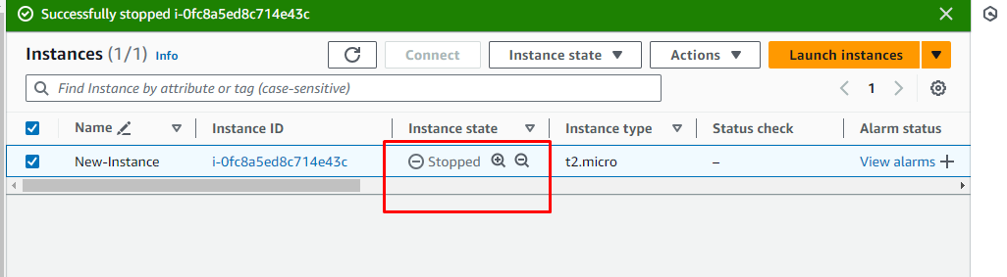

**Steps 2 : Start An Instance**

* + - 1. Go to Instance State and click on Start Instance
      2. You can see it running now (after restarting your server your public Ip Address get changed but your private Ip address remains constant.
      3. So you have to copy the new public Ip Again and paste it to your web browser again to see your webserver.

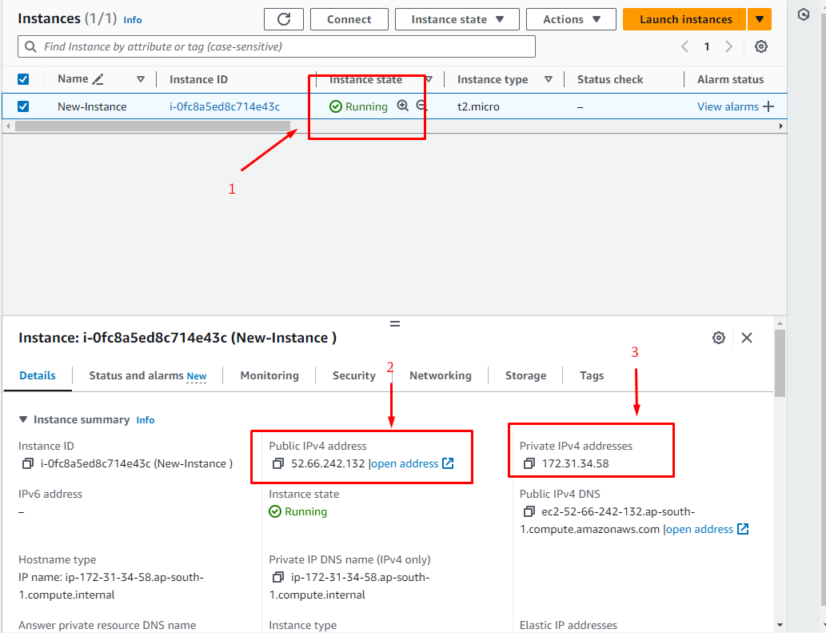

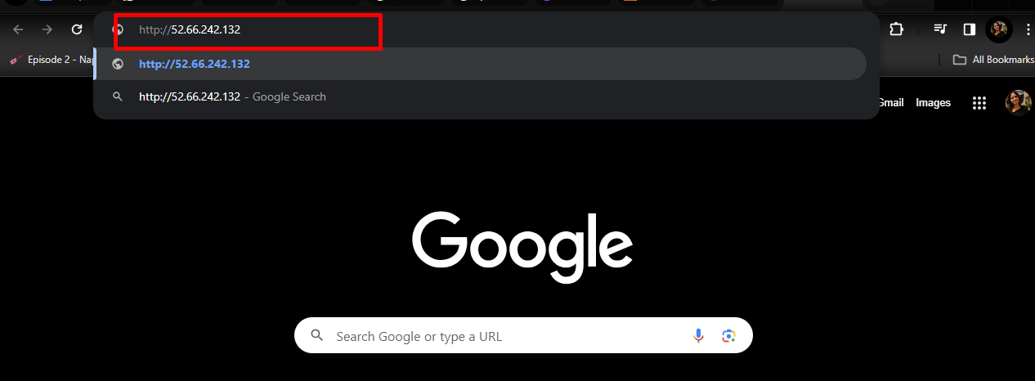

**Output:**

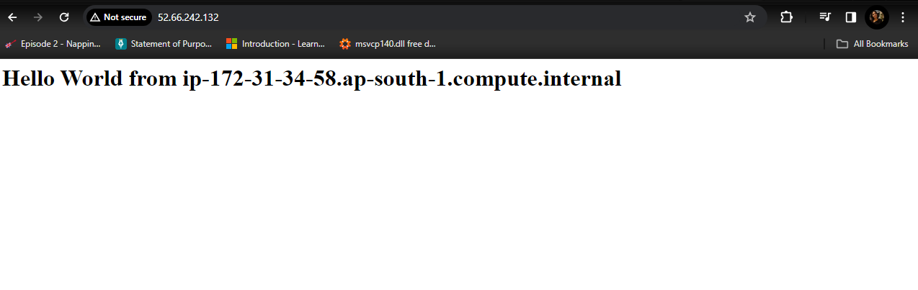

**Steps 3: Terminate an Instance**

* + - 1. Go to Instance State and click on Terminate